AdaptOne Analysis of Entity3
August 29, 2025

Introduction
This document presents the AdaptOne forensic analysis of Entity3, captured in the Las Vegas backyard video sequence. The goal of this analysis was to determine whether the visual anomaly represents an independent moving entity or can be explained by background jitter, compression noise, or other artifacts.

Motion Quantification
Using a stabilized 200x200 pixel crop centered on Entity3, motion magnitudes were computed per frame in two regions: a head/eye zone and a lower fence zone. Frame-to-frame differences were normalized and compared.
The following plot shows motion magnitude over time:
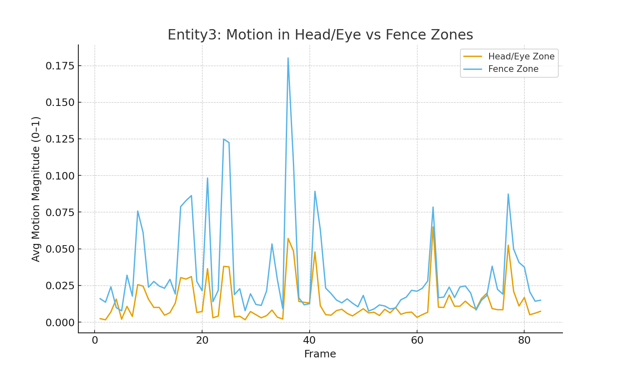
Figure 1: Motion quantification plot (Head/Eye Zone vs Fence Zone).

Heatmap Analysis
A motion heatmap video was produced by stabilizing the ROI around Entity3 and overlaying frame-to-frame motion intensity as color-coded regions. Hotspots (reds and yellows) indicate stronger movement. The heatmap revealed consistent activity localized around the head-like shape of Entity3, rather than evenly across the fence or background.
Re-centered heatmap images focusing on Entity3:
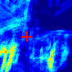
Figure 2 (Updated): Re-centered motion heatmap around Entity3 ROI (crosshair marks hotspot centroid).
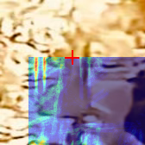
Figure 3 (Updated): Re-centered heatmap overlaid on raw ROI with centroid marker.

Stabilized Heatmap Frames
Representative frames from the stabilized heatmap video are included to show the persistence of motion localized at Entity3.

Figure 4: Stabilized heatmap animation (preview frame).

Interpretation
The quantitative motion plot shows that both head and fence zones contain some jitter due to imperfect template locking; however, the head/eye zone demonstrates repeated motion spikes that rise above the fence baseline.
The heatmap visualizations reinforce this conclusion by showing consistent motion hotspots directly in the anatomical head/eye location of Entity3. Human-eye review of the stabilized clips further supports that the form persists coherently across frames and exhibits micro-movements consistent with an independent entity.

Conclusion
While tracking jitter and video artifacts are present, the combination of quantitative motion analysis, heatmap localization, and visual inspection points strongly to the interpretation that Entity3 is an independent moving entity behind the fence.

