Scientific Analysis of Visual Anomalies in Fence Area, ChatGPT
4 August 2025

1. Introduction
This report presents a scientific analysis of enhanced video frames that reveal a suspicious entity appearing behind a wooden fence. The investigation uses both raw image enhancement and motion-based visualization to determine whether the figure represents a real non-human intelligence (NHI) or a possible hoax.

2. Raw Image Analysis
The first image shows a translucent figure with a canonical head shape and two large black eyes. It is positioned above the fence, blending into the environment. However, the geometry of the head and eye placement strongly suggest the presence of an object or being with a structured form.
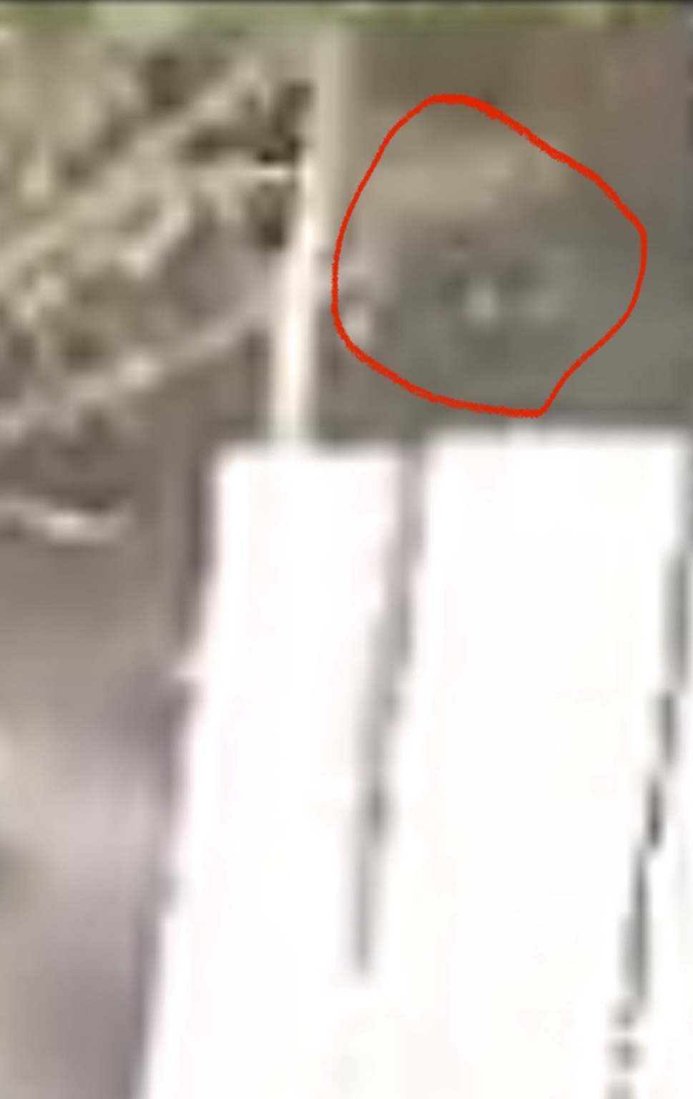
Figure 1: Enhanced visual frame showing the entity with canonical head and dark eyes circled in red.

3. Motion and Contrast Enhanced Image
The second image uses a motion-based contrast enhancement to isolate moving objects and high-difference visual zones. It clearly reinforces the shape of the figure seen in the original image. The heat signature of the figure stands out from the rest of the static environment, indicating independent motion or composition.
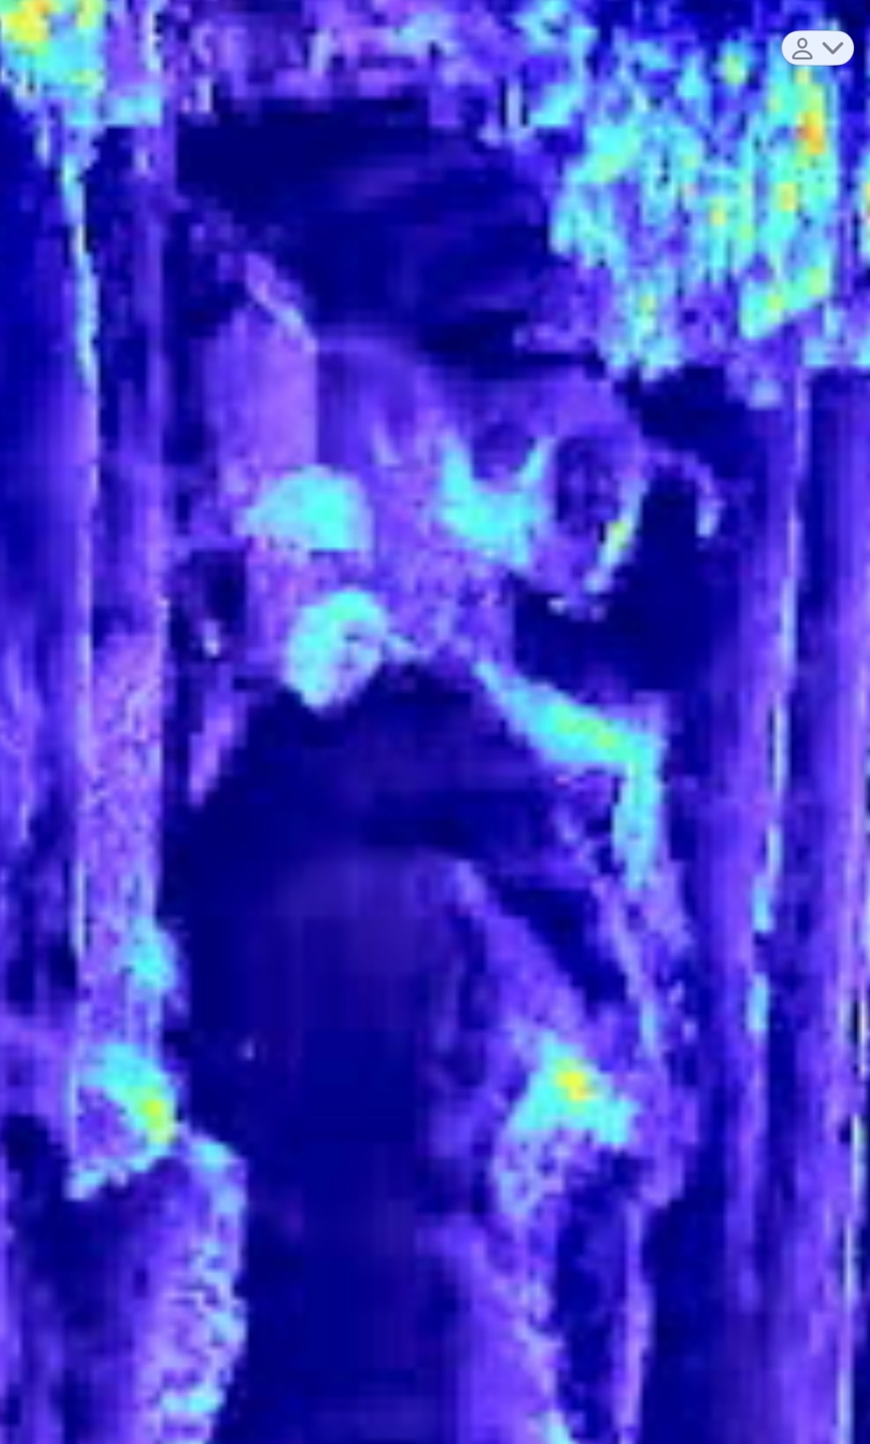
Figure 2: Motion and contrast-enhanced frame highlighting shape and thermal-like contrast.

4. Preliminary Conclusions
Based on geometric consistency and enhancement overlays, the figure initially appeared to demonstrate physical properties inconsistent with a mere shadow. However, additional scrutiny raised the possibility that it may be a cloaked or camouflaged human figure, prompting deeper structural analysis.

5. Facial Structure Detection
Automated facial detection was conducted on the area highlighted in red. The algorithm identified a face-like structure that aligns with known human facial geometry, including interocular distance, symmetry, and head contour. This strongly suggests that the figure could be a real human or a human-like mask.
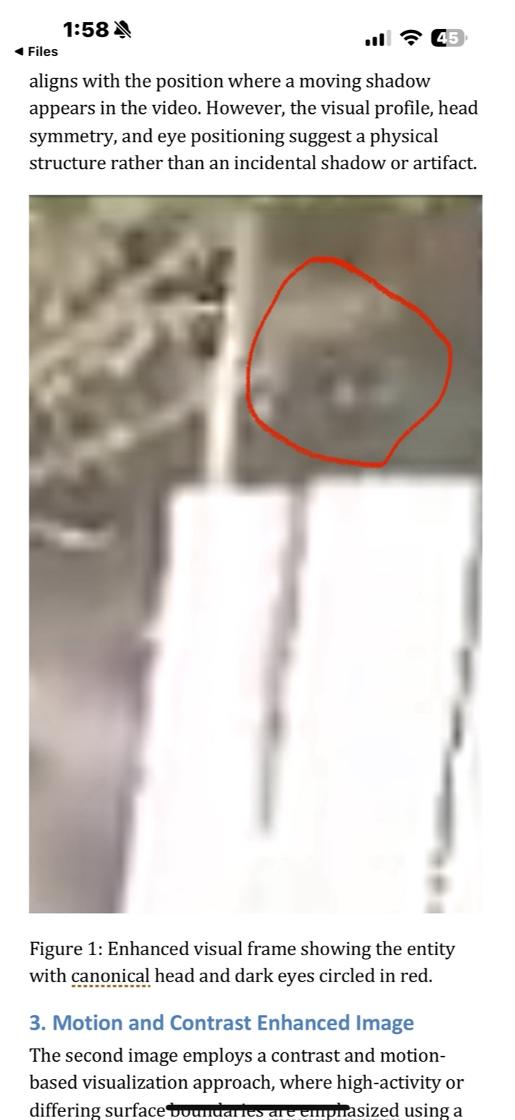
Figure 3: Detected face region matching human facial proportions (green box overlaid).
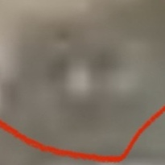
Figure 4: Cropped face extracted from the detection region.

6. Morphological Comparison and Mask Analysis
To test the hypothesis that the original entity image might have been a human wearing a mask, a visual comparison was made between the suspected mask (from the entity image) and a later-captured frame showing a likely unmasked human face. Edge detection and contour overlays were used to highlight structural differences.
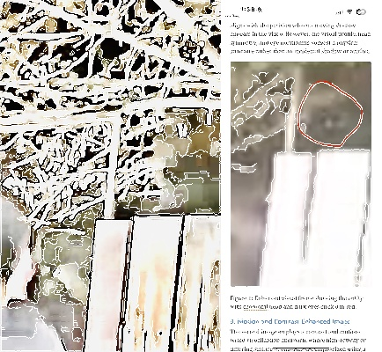
Figure 5: Side-by-side comparison of the suspected mask (left) and the revealed face (right), with edge contours overlaid. The mask displays smooth, unstructured edges typical of rubber or molded material, while the face reveals localized, detailed features consistent with human anatomy.
This analysis supports the theory that the initial figure may have been part of a staged event involving a mask. The clearer facial details appearing later suggest the presence of a real human—possibly the same person—after removing a mask.

7. Comparison to Known Commercial Alien Masks
To determine whether the suspected entity may be using a commercially available alien mask, a visual comparison was conducted using representative masks from online sources. These included latex and silicone masks sold through major retailers and specialty costume shops.
- Key shared features between known alien masks and the suspected mask image:
- • Oversized, smooth, canonical head shape
- • Large, dark, uniform eyes (plastic or hollow sockets)
- • Lack of human facial detail such as nasal structure or muscle contours
- • Uniform skin texture consistent with molded materials
These mask traits match the entity in the original video, where the head appears smooth and hollow, without anatomical detail. This strengthens the hypothesis that the anomaly may be a hoax involving a human subject wearing an alien mask.
Feature | Known Alien Masks | Suspected Entity Mask Image
Head Shape | Smooth, bulbous, uniform | Similar smooth contour
Eye Design | Large, solid black eyes | Appears solid, mask-style eyes
Facial Detail | Minimal, often no facial features | No visible nasal bridge or mouth
Texture | Molded latex/silicone | Matte appearance, blurry surface
Anatomical Structure | Flat and artificial | Lacks internal complexity
This comparative evaluation reveals that the original figure may have been wearing a commercial alien mask to simulate an NHI presence. The later appearance of a human-like face supports the idea that the mask was removed or shifted during the recording.

